
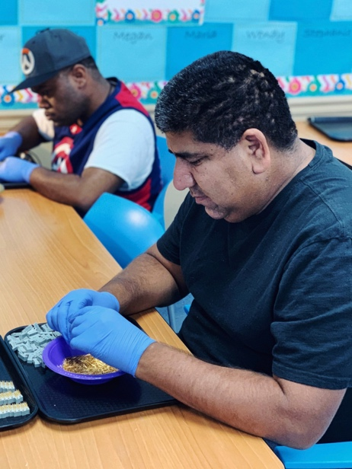
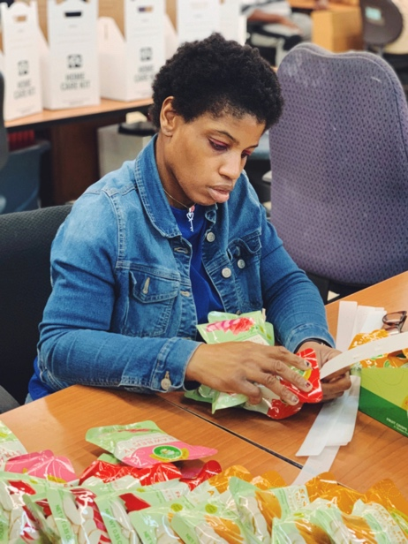

Annual Report
FY2024
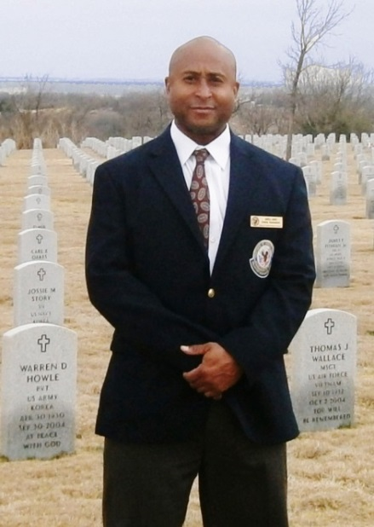
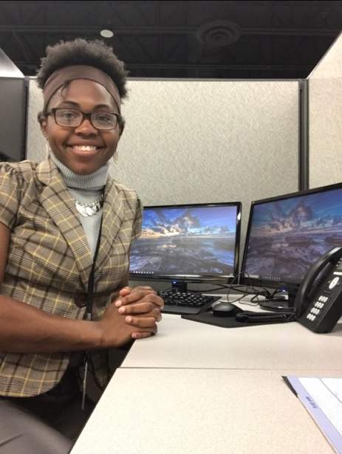
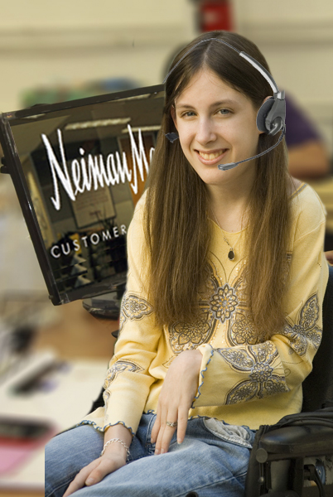

Big Bright Light Metrics – FY2024
- Annualized Earnings: FY24 - $8,851,289
- Transportation Made Accessible: FY24 - 319
- Individuals Placed in Jobs: FY24 – 237
- Empowered with New Skills: FY24 – 294
- Work Hours – Severe Disabilities FY24 – 30,531
- Backpacks Distributed: FY24 – 195

Service Numbers - FY2024
In FY2024, we served a total of 1,219 individuals. Below is an 8-year comparison chart:
 | FY2024 | FY2023 | FY2022 | FY2021 | FY2020 | FY2019 | FY2018 | FY2017
Total Served | 1219 | 1092 | 1,100 | 1,087 | 986 | 1,090 | 968 | 696
Day Programs | 120 | 115 | 105 | 163 | 178 | 197 | 209 | 209
Employment | 1099 | 977 | 995 | 924 | 808 | 893 | 759 | 487
Placements | 237 | 168 | 191 | 195 | 182 | 200 | 189 | 120

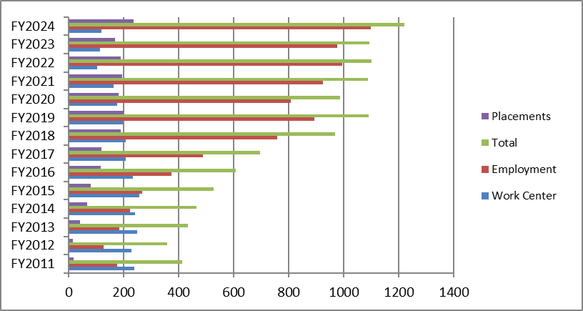

Participant Demographics – FY2024

Disability (Percentages will add up to more than 100% as some clients have more than one disability)
FY 2024 Clients’ Disabilities | Day Programs (Work Center and Academy) |  | Employment  (VR and Veterans) |  | High School Work Readiness Training
Intellectual Developmental Disability | 97% |  | 4% |  | 74%
Mental Health | 16% |  | 40% |  | 3%
Physical Disability | 14% |  | 73% |  | 3%
Substance Abuse | 0% |  | 33% |  | 0%
Visual/Hearing Impairment | 13% |  | 8% |  | 6%
Epilepsy | 20% |  | 1% |  | 3%
LD/BIF/TBI | 0%/2%/1% |  | 2%/0%/8% |  | 24%/0%/3%
2 or More Disabilities | 49% |  | 47% |  | 15%
3 or More Disabilities | 13% |  | 14% |  | 3%
High school work readiness training programs include Vocational Adjustment Training, Work Experience, Pre-ETS Training, and Embedded Training.

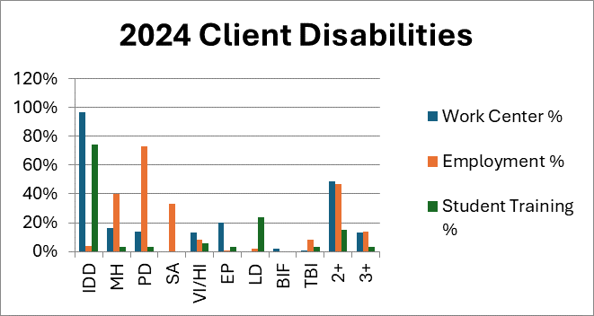

Race/Ethnicity

Program | African-American | % | Caucasian | % | Hispanic | % | Asian | % | Other | % | Ttl
Work Center | 78 | 65% | 22 | 18% | 19 | 16% | 0 | 0% | 1 | 1% | 120
Employment/Work Readiness T | 701 | 64% | 272 | 25% | 99 | 9% | 12 | 1% | 15 | 1% | 1099
Total | 779 | 64% | 294 | 24% | 118 | 10% | 12 | 1% | 16 | 1% | 1219

Age

Program | 13-18 | % | 19-21 | % | 22-44 | % | 45-59 | % | 60-64 | % | 65+ | % | Total
Work Center | 0 | 0% | 0 | 0% | 71 | 59% | 34 | 28% | 8 | 7% | 7 | 6% | 120
Employment/ Work Readiness Training | 15 | 1% | 39 | 3% | 314 | 29% | 275 | 25% | 186 | 17% | 270 | 25% | 1099
Total | 15 | 1% | 39 | 3% | 385 | 32% | 309 | 25% | 194 | 16% | 277 | 23% | 1219

Gender

Program | Male | % of Total | Female | % of Total
Work Center | 74 | 62% | 46 | 38%
Employment | 911 | 83% | 188 | 17%
Total | 985 | 81% | 234 | 19%

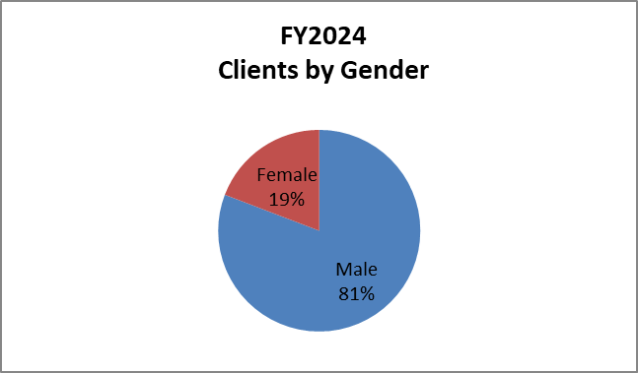

Household Income

Total Agency Work Center/Academy Employment
83% Under $24,300 58% Under $24,300 86% Under $24,300
8% $24,300 – $35,850 19% $24,300 – $35,850 6% $24,300 – $35,850
5% $35,851 - $57,350 12% $35,851 - $57,350 4% $35,851 - $57,350
4% Over $57,350 11% Over $57,350 4% Over $57,350

Counties

Program | Dallas | Collin | Tarrant | Denton | Ellis | Kaufman | Rockwell | Houston/ Galveston
Work Center | 96% | 1% | 0% | 0% | 2% | 1% | 0% | 0%
Employment | 71% | 4% | 18% | 2% | 1% | 1% | 2% | 1%
Agency-Wide | 73% | 4% | 16% | 2% | 1% | 1% | 2% | 1%

Additional Demographics

Employment Services:
237 Individuals place in employment
2.2 Months on average to obtain employment
$18.47 Average hourly salary
94% Full-time employment (compared to part-time)
93% 3-month job retention
84% 6-month job retention
33% Substance abuse history
37% Criminal history
50% Some college education and/or college degree
21% Currently receiving mental health services
183 Employers
88% Placed clients were veterans (208 of 237)

High School Work Readiness Training Programs
86% Special education history
60% Less than high school education
95% No employment history
74% Transportation dependent

Work Center/Academy Programs
96% Special education history
3% Less than high school education
78% No employment history
99% Transportation dependent

Outcomes

Employment Program
We evaluate the impact of our Employment Program by measuring job placements, placement metrics, and job retention.
Goal: 200 individuals with disabilities will be placed in community employment.
Outcome: 237 individuals with disabilities were placed in community employment.

Goal: 3 months or less average from service initiation to job placement.
Outcome: 2.2 months average from service initiation to job placement.

Goal: 85% placed in full-time employment (compared to part-time)
Outcome: 94% placed in full-time employment (compared to part-time)

Goal: $15.00 average hourly wage
Outcome: $18.47 average hourly wage

Goal: 90% of employed clients will maintain successful employment for 3 months.
Outcome: 93% of employed clients maintained employment for 3 months

Goal: 85% of employed clients will maintain successful employment for 6 months.
Outcome: 84% of employed clients maintained employment for 6 months.

Youth Work Readiness Programs
We evaluate the impact of our Youth Work Readiness Programs by measuring successful module completion and improvement of skills.
Goal: 92% of students who successfully complete their training module will improve their communication, interpersonal, job preparation and/or soft skills.
Outcome: 93% of students who successfully completed their training module improved their communication, interpersonal, job preparation and/or soft skills.

Goal: 95% of students will successfully complete their designated training modules.
Outcome: 100% of students successfully completed their designated training modules.

Day Programs
We evaluate the impact of our Day Programs by measuring our clients’ achievement of their individualized goals.
Goal: 93% of program participants will achieve their monthly goals.
Outcome: 92% of program participants achieved their monthly goals.

Major Accomplishments and Impact
- Awarded and implemented a 3-year/$320,000 per year federal grant from the Department of Labor’s Homeless Veterans’ Reintegration Program (HVRP) to provide case management, training, employment, and support services to veterans experiencing homelessness so that they can obtain excellent quality jobs and transition from homelessness to independence and self-sufficiency. The grant began on July 1, 2023 and goes through June 30, 2026. We served 7 counties - Collin, Dallas, Denton, Ellis, Kaufman, Rockwall, and Tarrant, and we achieved all program outcomes.
- Awarded a 2024-2025 renewal grant from the Texas Veteran Commission grant to provide employment services to veterans with disabilities at an increased funding level from previous years due to meeting all previous grant year performance outcomes.
- Awarded a continuation grant from the City of Dallas to provide job placement services, forklift training and bus passes to low- income individuals, ages 60 and older, who live in the City of Dallas due to meeting all previous grant year performance outcomes.
- Expanded our day program services and began providing weekly community outings for all clients in our Academy and Work Center Programs.
- Selected by DISD to be their service provider for Project SEARCH, our newest U&I program. Project SEARCH is an innovative business-led school-to-work training program that provides students with disabilities with competitive and marketable job skills at a host business site. The ultimate goal for this program is competitive employment. It is a longer and more intensive job experience program than work experience. Our Project SEARCH program will start in the 2024-2025 school year, and it will consist of a partnership with TWS-VR, Dallas ISD, Metrocare Services, and Baylor Medical Center.
- Partnered with the University of North Texas’ Texas Beacons of Excellence Program. They received a Department of Education grant to transition individuals from 14c employment to community employment. UNT staff conducted several trainings for our employees and are currently working with 10 of our day program clients.
- Hosted our second on-site, annual Veteran Job Fair. The Job Fair included both employers and resource agencies. Veterans were provided with a haircut, fully loaded backpack, resume review, interview skills training, breakfast and lunch.
- Hosted our annual Mix, Meet, and Eat event. Guests enjoyed a facility tour, presentations on current programs and future plans, and a delicious lunch. Many connections were made.
- Continued the successful administration of the Work Experience Wage Services Program for the Texas Workforce Commission-Vocational Rehabilitation Services. As the employer of record for this program, we handle the onboarding, timesheets, payroll, and workers compensation for interns with disabilities working throughout the State of Texas. Under our management, this program continues to rapidly expand.
- Provided computer training in our new Opportunity Lab to all direct service employees.
- Received 100% compliance on our City of Dallas grant audit, Department of Labor 14c audit, HVRP monitoring review, and Dallas MetroCare audit.
- Awarded the 2023 Gold HIRE Vets Medallion due to our great job of hiring veterans to work for U&I.
- Maintained our Platinum Seal of Transparency.
- Implemented a new electronic employee and client timekeeping system.
- Expanded our veteran employment services to the Houston area,
- Partnered with DART for their annual bus pass savings plan.
- Renovated portions of our building. New flooring was installed, office and hallway walls painted white, and new office furniture added. The walls that experienced water intrusion were removed and new walls installed.

Partnerships 2024
Employers
7-Eleven Five Guys Priffert Steel
A&A Staffing Five Star Waste Recycling Progress
A.C.E Fort Worth VA ProSource Solutions
ABM Aviation Fortress Building Products Puppy Dreams
Aero Star Aviation Game Stop Randstad
All State Gardaworld Security Recycle Revolution
Allied Aviation Geddis Regal Staffing
Allied Barton George O’Days Renaissance Hotel
Allied Universal Security Goodwill Results Staffing
Aloe Vera Greyhound Robert Half
Amazon H&H Xpress Ruch Peterbilt Trucking
American Income Life Insurance Harley Davidson Ruthie’s Food Truck
American Mil-Spec Services Harris Packaging Ryco Roof
American Well Services Hilton Safety 1st Trucking
Ameritex Vending Home Depot Sage Synergy
Anchor Fabrication Honor Home Care Salcomp
Andy Frain Security Hope Horizon Salon Wholesale
Aramark IIDon Salvation Army
Arboretum Image Retrieving Sandman Signature Hotel
Ashley Furniture Integrity Porter Shadow Systems
AT&T Inter-Con Security Systems Signature Garment Care
ATM Painting Invasion Dallas Simon Hegele
BBQ Chicken Iron Mountain Sky Smoke Shop
Belmar Services J&A Signs Sleeptronic
Berger Engineering John Eagle Honda Soliz Concrete & Plumbing
Big D tool Center JR New Energy Sonic
Bonton Farms Just Answers Stack Path
Boss Truck Stop Justin Palmer Construction Staffmark
Buffalo Wild Wings Kenneth Copeland Ministries Stalker Radar
Builder First Source Kumiho Tire SVP Tempest
Care Center Ministries Lancaster ISD Swift Transportation
Caregiver Liberty Tax Taylor Farms
Centria Autism Lonestar Amphitheater Telsia Electric
City County Elections Lonestar Hazmat TX Dept Criminal Justice
City of Dallas Lowes The Parking Spot
City View Health & Rehab Lupe Tortilla Restaurant Tik Tok & Vaper
CJ Global Managed Labor Solutions Tom Thumb
CMX Solutions Manheim Town Place Suites
Collin County Public Works Marco’s Pizza Toyota.
Comprehensive Communications Markeu Protective Services Tru-Green
Construct Markman Security TX Valor
Cracker Barrel Masonic Lodge Tyson Foods
Credit RP Maximum Crime Prevention U&I
Critical Project Services McDonald’s Union Gospel Mission
CSC Security Mid Atlantic Parking Services Unica
D&L Security Modern American Mechanical Union Pacific Railroad
Dallas Center of Dermatology National Achives Unique Awnings
Dallas County District Courts Naval Air Station UNT Dallas

Dallas Love Field Nestle Health Science UPS
Dallas VA Hospital Nicky D’s US Express
DART Non-Emergency Transport USPS
DBI Construction Okon Recycling Center UT SW Medical Center
Department Homeland Security On Pointe Delivery VA – Fort Worth
DTX Vapor One Place Workplace Valassis
Ellwood Palmer ISD Walmart
Encompass Health Paw Spa Pet Groomer Waste Management
FedEx Pecan Deluxe Weiser Security
Federales of Dallas Pet Supplies Plus Wendy’s
Fidelity National Title Plano Day Labor Center White Rock Medical Center
First Step Plastipak Worth Ross
Positions
Accountant Flash Fuel Technician Program Manager
Aircraft Fueling Technician Forklift Driver Puppy Counselor
Armed Security Guard Groundskeeper Quality Technician
Analyst Hazmet Response Technician Rack Roller
Associate Home Health Aide Radar Technician
Bus Driver HR Assistant Receptionist
Caregiver Image Production Specialist Retail Clerk
Cart Attendant Installer Security Guard/Officer
Case Manager Insurance Agent Senior Plans Examiner
CDL Driver Inventory Clerk Senior Support Engin
CDL Instructor IT Server
City Carrier Assistant Job Coach Shift Supervisor
Clerk Laborer Shuttle Driver
Concierge Line Worker Software Engineer
Construction Worker Lobby Attendant Stocker
COO LVN Subject Matter Expert
Cook/Prep Worker Machine Operator Supervisor
Corrections Officer Maintenance Technician Supply Chain Technician
Crew Member Material Handler Talent Recruiter
Custodian/Janitor Mover Team Member
Customer Service Representative Night Auditor Teacher
Data Entry Operations Manager Therapist Technician
Delivery Driver Painter Train Crew Logistics
Diesel Mechanic Paraprofessional Transportation Manager
Dishwasher Parking Lot Attendant Truck Driver
Donation Attendant Parking Valet Vehicle Detailer/Cleaner
Driver Passenger Assistant Veteran Student Services
Driving Instructor Patient Transporter Warehouse Associate
Electrician Pipefitter Welder
Finance Associate Porter

Website/Social Media
- Website: uandispreadthelight.com
- Facebook: https://www.facebook.com/ItTakesUandI
- Instagram: https://www.instagram.com/ItTakesuandI/

